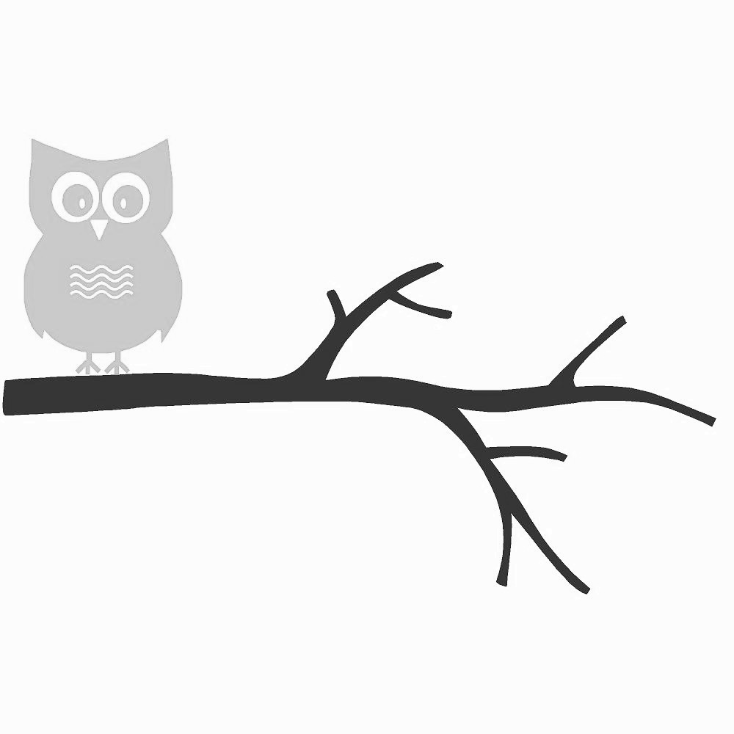

Community Helping Branch



*Template created by the Canadian Mental Health Association Nova Scotia Division’s Communities Addressing Suicide Together (CAST) Program*

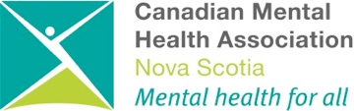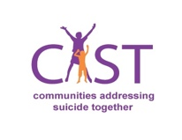

**Community**

**CMHA NS Division**

Place Logo Here